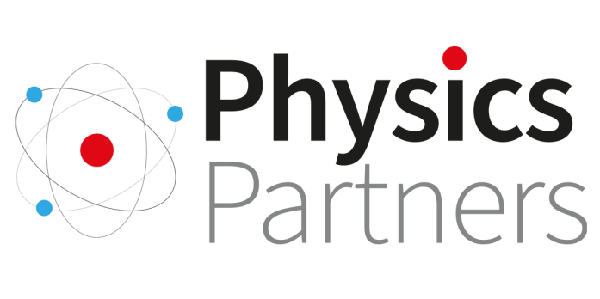

Re: East Midlands Festival of Physics at The Kimberley School on Saturday 29th June, 9.15am – 3.00pm

Dear

I am keen to attend this day of physics professional development specifically designed for non-specialist physics teachers taking place at The Kimberley School, near Nottingham (NG16 2NJ) on Saturday 29th June 2024.

The organisers are generously subsidising the cost of the day and only charging a nominal fee of £10 per person. This includes selection of three interactive workshop sessions, attendance at the keynote, and networking with fellow teaching colleagues over complimentary lunch, refreshments and an exhibition of STEM equipment suppliers and organisations. All workshop resources will also be shared with attendees.

I kindly request that the school covers the £10 fee to enable me to book a place. I can provide an invoice once booked.

I believe my attendance will greatly benefit both myself and our students and thank you for considering my request. I am happy to provide any further information or discuss this matter in person if needed.

Many thanks

